GA: Time taken for all generations: 4415.6203 seconds

JSON: saved_individuals_2

Params: 26

Fitness function: > 0.1

Mutation: 0.03

Crossover: 0.7

Tournament: 2

Generations: 15

Population: 30

GA: Time taken for all generations: 31533.5996 seconds

JSON: Saved_individuals_3

Params: 26

Fitness function: > 0.1

Mutation: 0.03

Crossover: 0.7

Tournament: 3

Population: 100

Generations: 40

ES: Time taken for all generations: 3861.5553 seconds

JSON: saved_indiviudals_4

Params: 26

Fitness function: > 0.1

Mutation: 0.08 with changing mutation step size

Tournament: 3

Population: 30

Generations: 15

GA MU+LAM: JSON

ES MU+LAM

Related Works:

<https://ieeexplore.ieee.org/stamp/stamp.jsp?tp=&arnumber=1609619>

can talk about some of the trading strategies they implemented (RSI and MACD)

<https://ieeexplore.ieee.org/stamp/stamp.jsp?tp=&arnumber=9960002&tag=1>

multi objective optimization

<https://www.researchgate.net/publication/248816697_Genetic_Algorithms_In_Economics_and_Finance_Forecasting_Stock_Market_Prices_And_Foreign_Exchange_-_A_Review#full-text>

genetic algo

<https://eds.s.ebscohost.com/eds/detail/detail?vid=0&sid=46385804-bae6-40e8-a3ae-07989069e85c%40redis&bdata=JkF1dGhUeXBlPWlwLHNoaWImc2l0ZT1lZHMtbGl2ZQ%3d%3d#AN=edseee.6889969&db=edseee>

neural network improvement

<https://eds.s.ebscohost.com/eds/detail/detail?vid=12&sid=94638792-c9c9-4b25-844b-c66679d793b0%40redis&bdata=JkF1dGhUeXBlPWlwLHNoaWImc2l0ZT1lZHMtbGl2ZQ%3d%3d#AN=143759660&db=aqh>

CNN improvement

<https://eds.s.ebscohost.com/eds/detail/detail?vid=13&sid=94638792-c9c9-4b25-844b-c66679d793b0%40redis&bdata=JkF1dGhUeXBlPWlwLHNoaWImc2l0ZT1lZHMtbGl2ZQ%3d%3d#db=edscma&AN=edscma.3292441>

Genetic neural networks

TENSE

Forward tested or forward-tested

References:

Conclusion:

Going forward I would like to look into testing on live data because results could be different. Try to get access to more data (larger historical time period), look at getting even more granular data (tick data). Add more evolutionary strategies so that other parameters can be mutated/changed.

Experiments:

Setup:

Might want to explain the trading strategies.

GA: Time taken for all generations: 3590.7175 seconds

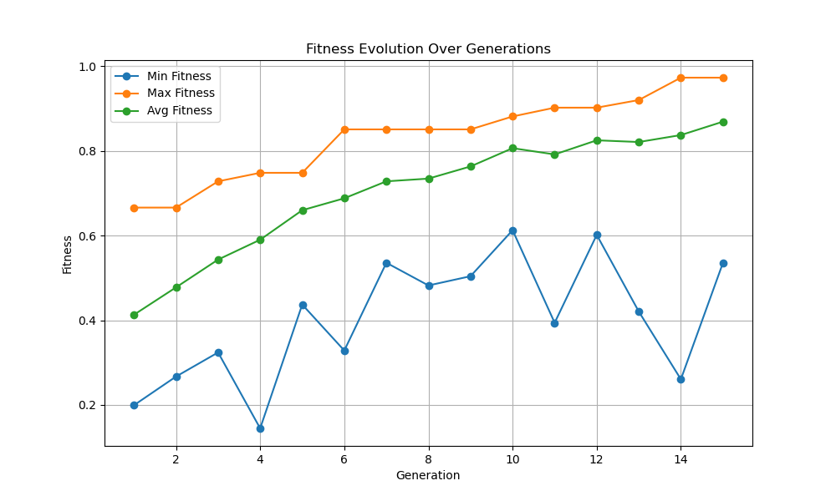JSON: Saved_individuals_6

GA: json saved_individuals_6

28474.9442 seconds

Generation 75

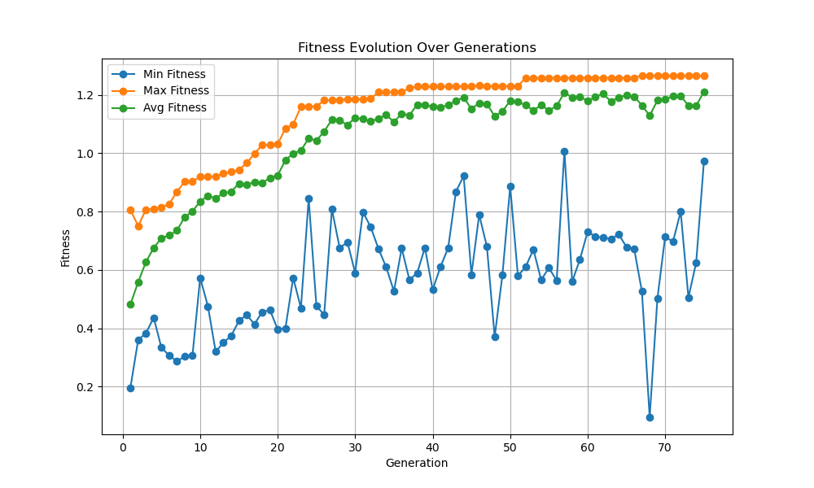Population 50

EP JSON 8

Time taken for all generations: 3740.4855 seconds

GA: JSON 9 Time taken for all generations: 3800.5770 seconds

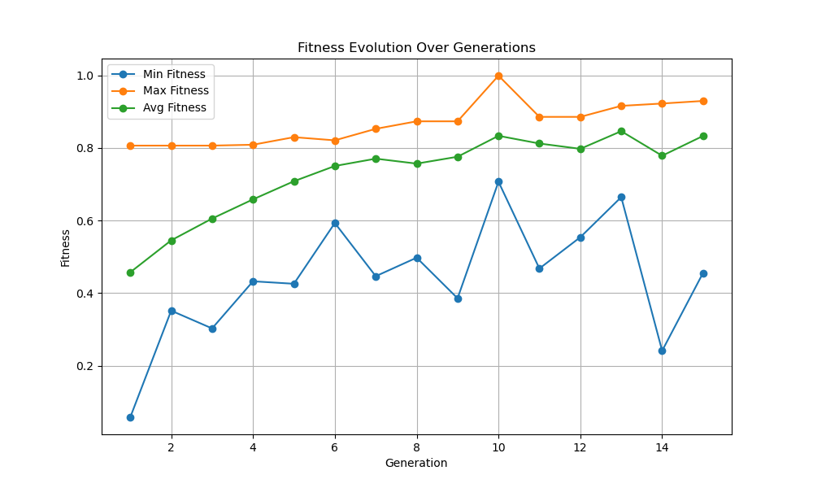

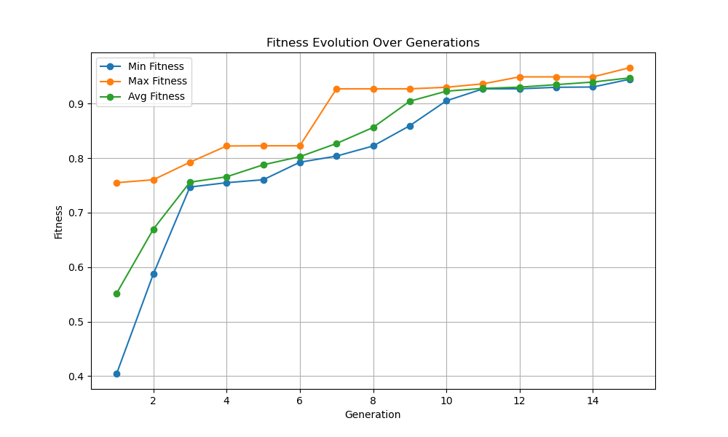GA MU+LAM JSON 10: 4428.8869